**National University of Computer & Emerging Sciences**

**Karachi Campus**



**Project Report**

**MIND FRAME ASSISTANT**

**Programming Fundamentals**

SECTION: BCS-1H

INSTRUCTOR: SIR TAHA AHMED

Group Members:

22k-4459 Aqsa Masood

22k-4413 Syeda Fakhira Saghir

22k-4499 Muhammad Raza

**MIND FRAME ASSISTANT**

***Role and contribution of each member in the project:***

The logic building and main use of strtok function and mood determination was a combined effort. Deciding on the outputs and making the strings was equally divided by the three of us. However, when it comes to the other parts of the code: the structures and data management were done by Aqsa Masood, Syeda Fakhira Saghir worked on the filing part of the code and Muhammad Raza managed the random generation of numbers in the functions as per the number of strings stored in each file and output of the questions and answers in a random manner.

1. **Main Idea**

The Project determines the mood of the user and displays a message according to their mood. It also answers their questions in relevance to their mood. My team and I got the idea from Magic Ball 8, it randomly answers questions from users. However, our project is slightly different from what Magic Ball 8 is. The outcome of our project will be a program: It firstly evaluates the user’s mood and gives options for further assistance that will allow the user to either get their mood determined again or provide them with answers to YES/NO questions that will make them feel better, or give them a motivational quote, or recommend a book, according to the user’s choice of option.

**Goals**

The goals of this project are as follows:

**FUNCTIONAL GOALS:**

* To determine the mood of the user
* To answer accurately according to the mood
* To answer the questions asked by user

**TECHNOLOGICAL GOALS:**

* System to be reliable.
* System being user-friendly.

**Tools and Technologies**

* IDE used: Dev-C++.
* Libraries used: stdio.h, stdlib.h. string.h, time.h

**Future Work**

The system can be enhanced by taking the system to the web server which will eliminate the limitation of the system to only PC users. It will be accessible to anyone at any time. The basic structure of this system can also be reused in future works as the tools are modern and efficient.

The user interface can also be improved by deploying proper UI/UX developers but as for now, the system should fulfill the basic requirements.

1. **Main Features**

* Determining the mood of the user
* Different random messages for the user after mood determined
* Random output for yes/no questions
* Switch case for other assistance options like outputting a motivational quote or recommending a book.

1. **Code Snippets**

**-Determining the mood of the user:**

We have initialized strings for synonyms of 6 basic emotions stored in them. The emotions are happiness, sadness, anger, surprise, and disgust.

Using the *strtok function uses pointers* to make tokens and comparing each token with strings that have synonyms of 6 basic emotions stored in them.

If a match is found *a message according to the user’s mood* is printed randomly.

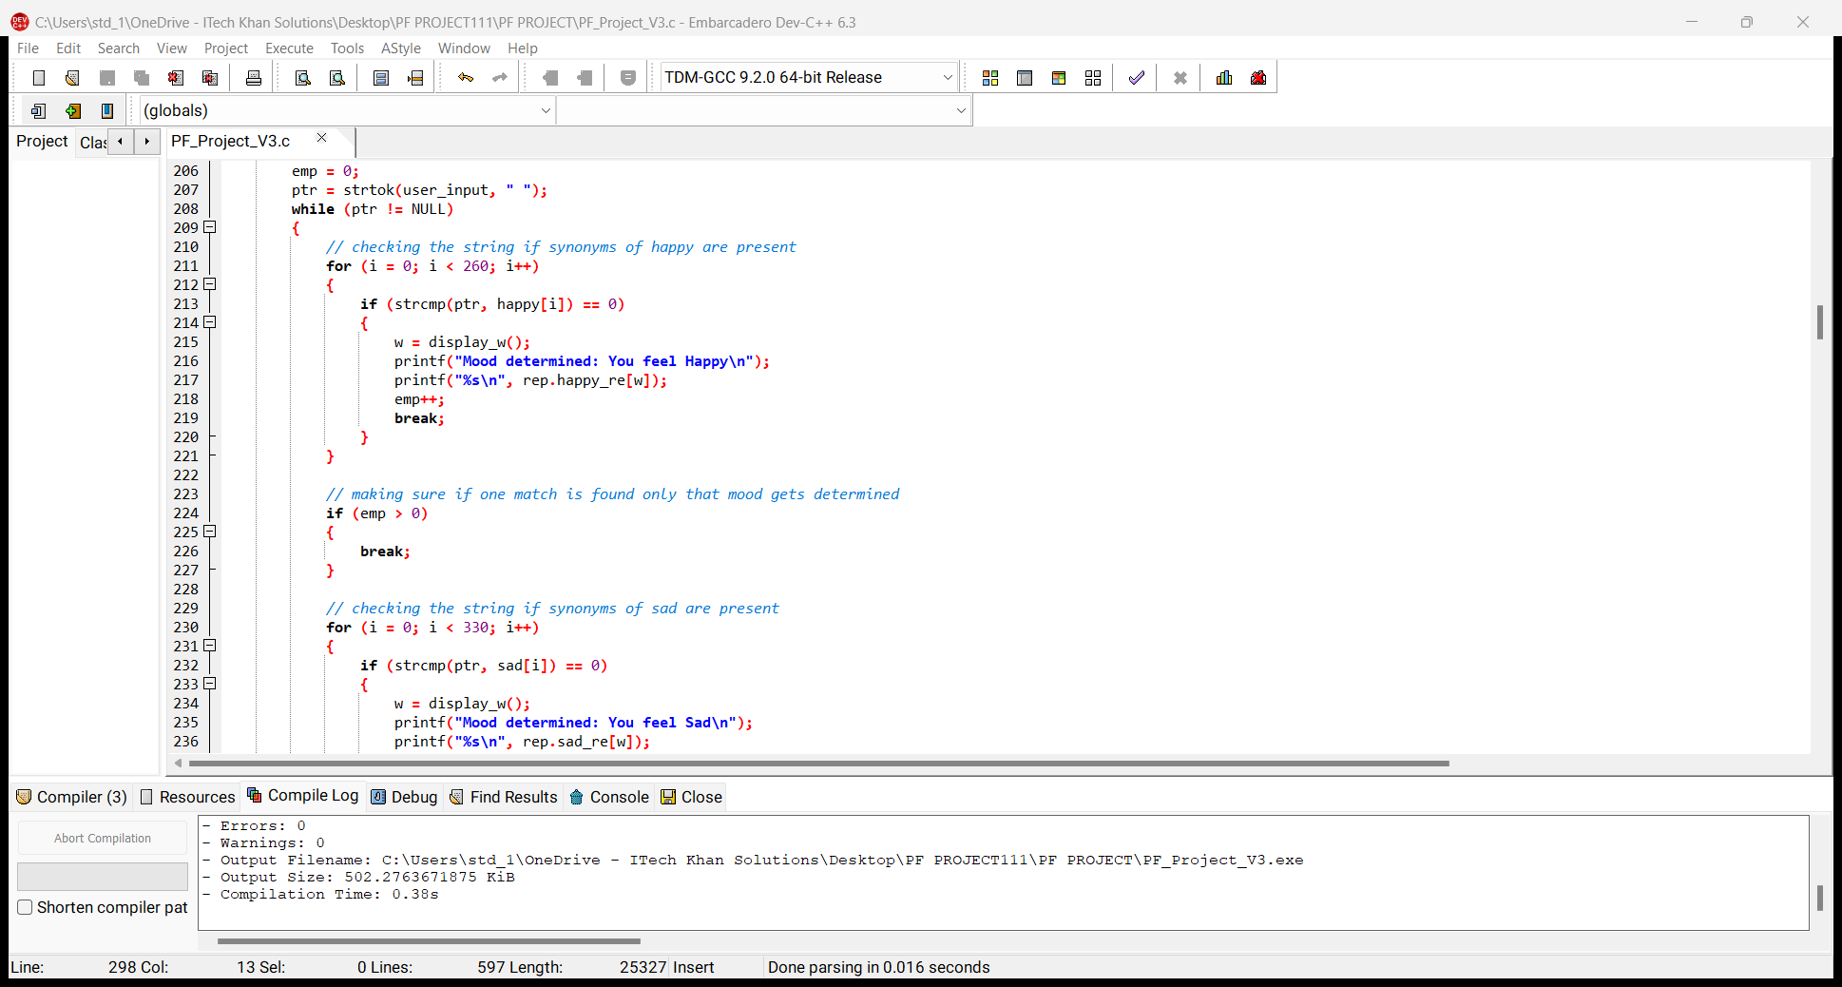

**-Use of Switch Case Statements:**

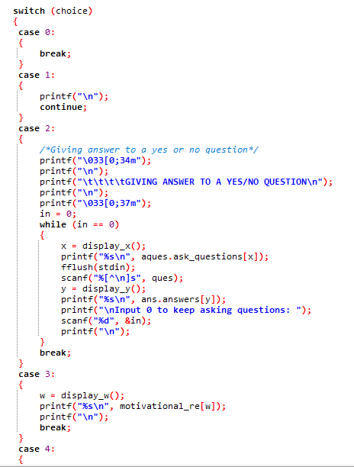

To provide *multiple options* to the user after the determination of the user’s feelings we used Switch case to offer further assistance.

**-Printing new question/answer every time the program starts:**

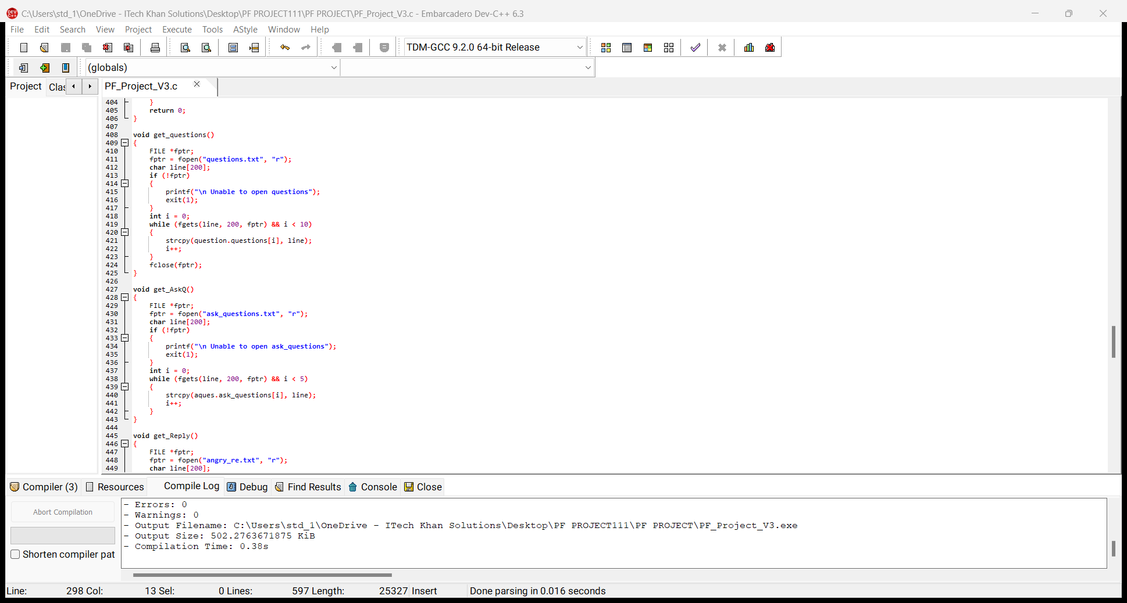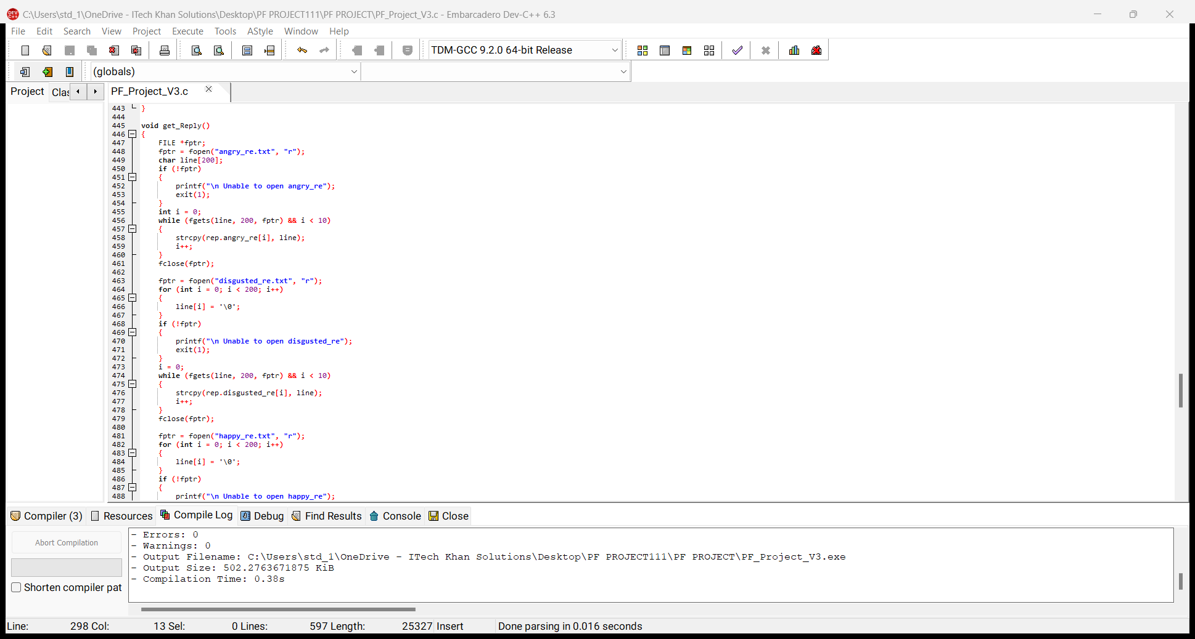

Questions to ask user to input their mood and questions to ask user to input a yes/no question are stored in *.txt files*. Likewise, messages for each mood and replies to y/n questions are stored in .txt files as well. We have used filing to read those files and store them in a string. These strings are declared using structures.

**-Using random numbers to print outputs:**

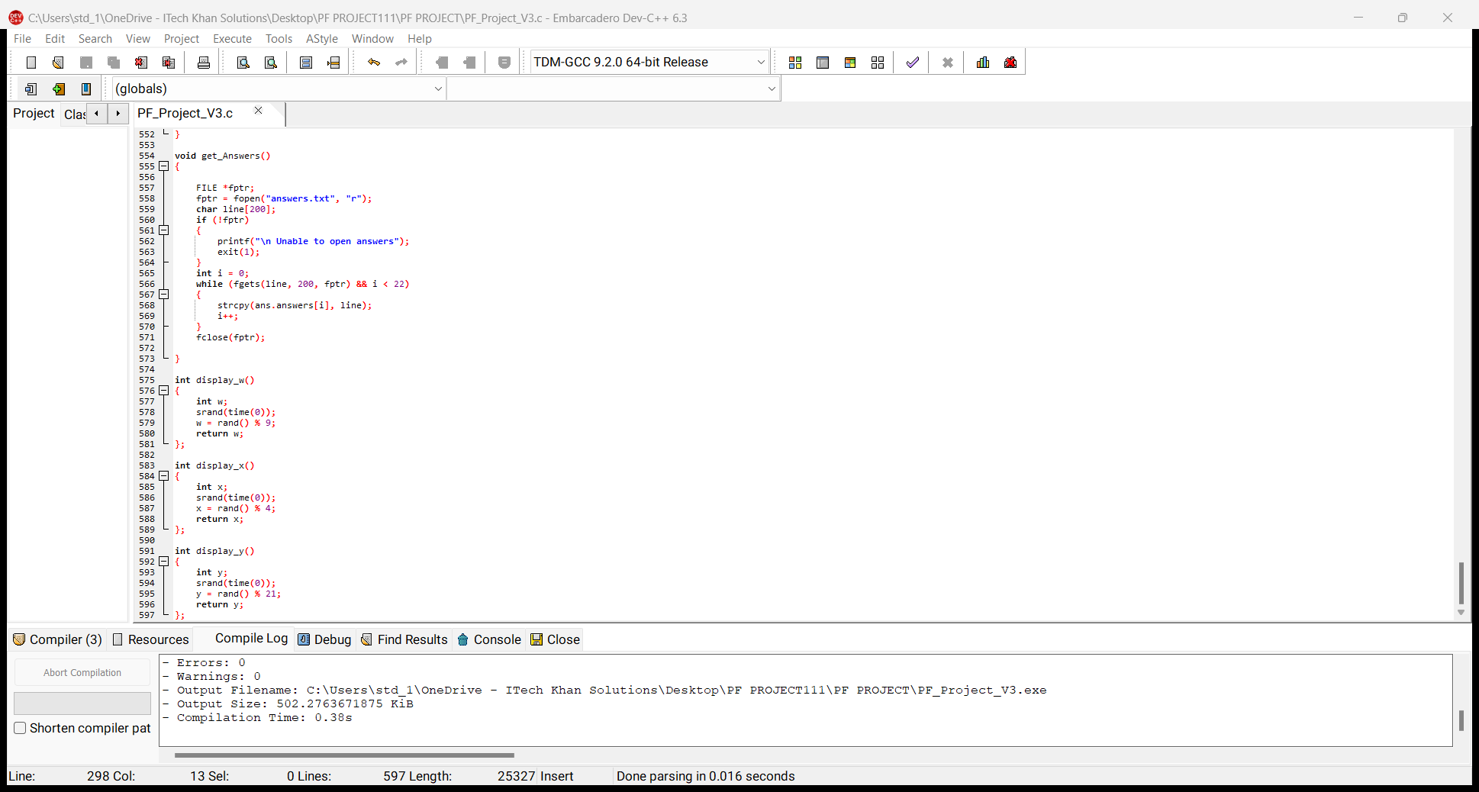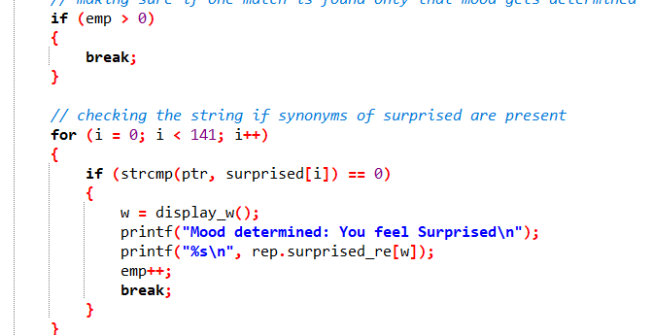

The functions to generate random numbers are made. The functions are called multiple times in the code: to output messages for the 6 random emotions, to output random questions each time the user wants to ask a question, and to output appropriate printf statements every time the user wants to get their mood determined.

1. **Problems Encountered**

At first, we were using loops to separate words in the user input, for that we had to count words in the user input. However, we soon realized that the more efficient method to separate each word in the user input would be to make tokens and then compare those tokens with the synonyms in pre-defined strings. This also made our program optimized.

Managing multiple counters to make sure that the program determines the users’ mood correctly was a little bit challenging, but we figured it out but placing multiple if conditions in our code.

Another problem we encountered was when we tried to print the colored text as output. We realized that Dev c++ didn’t recognize the graphic.h library so we found an alternative way to get the output in our desired colors.